Tutorial Question:
Tutorial 1: ATC-Pilot Communication MH370 Flight
Please listen to the communication between Kuala Lumpur ATCs and MH370 Pilot very carefully and answer following questions.
- What is the destination Airport for MH370? Beijing
- What is the Cleared Flight Level for MH370? FL 350
- What is the Squawk Code assigned to MH370? 2157
- What is the assigned runway of take-off for MH370? 32R
- How many passengers were on board MH370? 239
- What is the initial flight level MH370 was asked to climb before turning right to IGARI waypoint? FL 180
- What is the intermediate flight level, Kuala Lumpur Area Control asked MH370 to climb to? FL 250
- What was the frequency of Ho Chi Min ATC, MH370 was asked to contact? 120.9

Tutorial 2: ATC-Pilot Miscommunication: Case Study: Tenerife, 1977
Identify and discuss the Miscommunications Issues for following instances.

- English as a second language
  - Spanish ATC’s English pronunciation was unclear to the Pan Am pilots
  - Spanish ATC had instructed Pan Am to taxi down the runway and then to vacate the runway via the third taxiway, which Pan Am initially understood and read back correctly.
  - But following the read back, Pan Am Captain said to Pan Am First Officer, “I think he said first”.
  - Pan Am First Officer then asked Spanish ATC again to confirm on turning left at the third intersection, to which Spanish ATC replied, “The third one, Sir... one two three... third one”.
- Expectation error
  - We use expectation and context to hear and understand what has been said. Messages are misunderstood because the listener incorrectly infers the intended message.
  - In this scenario, KLM Captain had completed the turning of aircraft to Runway 30, FO had completed pre-takeoff checks, and Captain was eager/impatient to takeoff, evident by the premature throttle of aircraft before attanining ATC clearance, which FO highlighted to Captain that there was no ATC clearance yet to takeoff. Captain replied, “No... I know that, Go ahead and ask”, suggesting an attempt to cover his mistake on his oversight.
  - Unfortunately, Spanish ATC contributed to the expectation error by prematurely telling KLM the takeoff instructions (beacon to head towards, flight level and heading information) and using the word “cleared” in the mesage, giving the impression that KLM was cleared to takeoff. The intention of Spanish ATC was to give KLM a heads up on the takeoff information but wanted KLM to standby while waiting for Pan Am to clear the run way. Unfortunately, much of Spanish ATC’s following message, “OK...standby for takeoff...I will call you.” was conflicted with Pan Am’s transmission, and KLM only received the message, “OK”, which was interpreted as a go ahead to takeoff, but anyway by this time KLM was already 6 seconds into the takeoff due to the impatient KLM Captain.
  - When KLM FO communicated to Spanish ATC, “KLM4805 is now ready for takeoff...we’re waiting for our ATC clearance.”, Spanish ATC should have responded, “KLM4805, Tower, Hold” and only issue the takeoff instructions to KLM after making sure that Pan Am had cleared the runway.
  - KLM Captain had been too impatient and fixated on taking off, such that he might have not considered that there was another aircraft down the runway.
- Simultaneous transmission
  - Spanish ATC’s message to KLM, “OK...standby for takeoff...I will call you” was conflicted with Pan Am’s transmission, which KLM only receive, “OK” and was incorrectly interpreted as cleared for takeoff.
- Non-Standard phraseology
  - ATC phraseology was not adhered to by ATC, KLM, and Pan Am crews.
  - There was lack of using callsign for most transmissions.
  - Use of the word “OK” was to convey “I understand your message”, but sometimes misinterpreted as “I approve”.

Tutorial 3:
A flight (yellow arrow) transits through Washington Air Traffic Centre ZDC to JFK airport in New York Air Traffic Centre ZNY.
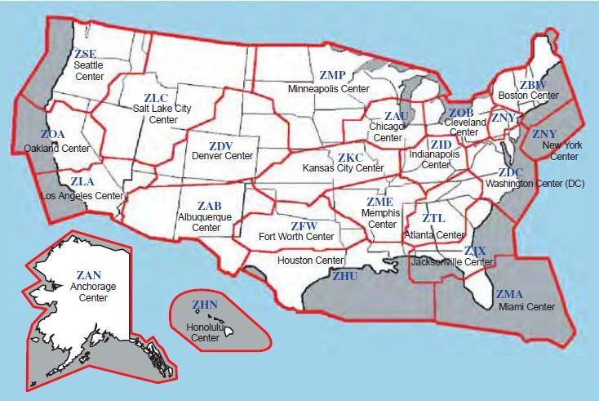
Figure 1: Washington Air Route Traffic Control Centre ZDC and New York Air Route Traffic Control Centre ZNY.

Please go through the audio and transcript in the attached “Morning Arrivals at JFK”, and follow the Flight 400 (call sign) from Washington ARTCC to the ramp at JFK Airport and answer following questions:
- The cursing Flight Level of Flight 400 in the Washington ARTCC was FL 380
- Washington ARTCC instructed Flight 400 to descend to flight level 370
- The frequency of Washington ARTCC is 125.45
- ATC instructed Flight 400 to cross HOGGS at altitude 18000 feet (instructed as Flight Level 180)
- The transition altitude for New York Approach Control is 11000
- Flight 400 is cleared to land on runway 31 Right
- To intercept the runway landing system (ILS), Flight 400 is instructed to fly heading 040
- The QNH value for New York JFK airport is 3003
- The frequency of New York Approach Control is 125.7
- At 3000 ft, New York Approach Control instructed Flight 400 to fly at speed 210
- The frequency of JFK Tower Control is 119.1
- Identify (Circle) the Initial Fix CATOD on the approach chart shown in Figure 2. See figure 2 below
- What is the reported distance between Embraer Jet and Flight 400 on final approach segment? 6 miles
- What is the wind speed at runway 31R? 020
- What is the frequency of JFK Airport Ground Movement Controller? 121.9
- Ground Movement Controller instructed Flight 400 to take Taxiway B

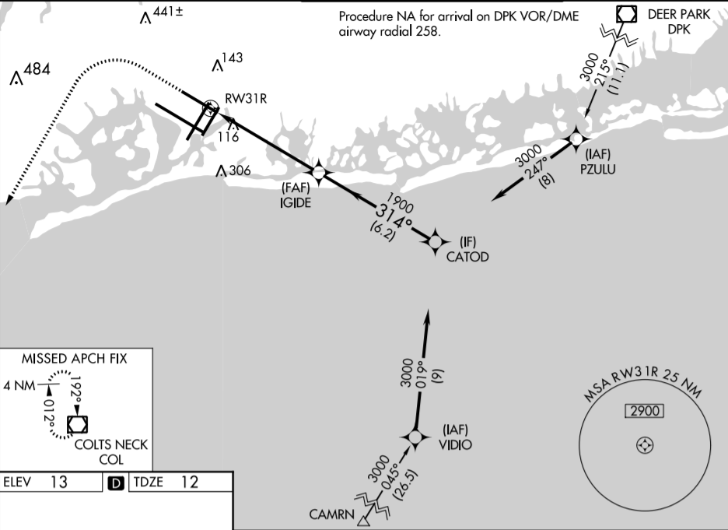
Figure 2: An Approach chart for JFK Airport

Tutorial Exercise 2:
What is communicated in each ATC message? Provide a written explanation.

1. Delta one-niner, after departure turn right heading one-two-zero, runway three cleared for takeoff
Heading: The compass direction in which the aircraft’s nose is pointed. There are 7 fundamental ways to determine the heading of a vehicle. Note that the heading may not necessarily be the direction that the vehicle actually travels, which is known as its course or track. Any differene between the heading and course is due to the motion of the underlying medium, the air or water, or other effects like skidding or slipping. The difference is known as the drift, and can be determined by the wind triangle. Heading is typically based on compass direction, so 0 deg (or 360 deg) indicates a direction toward true North, 90 deg indicates a direction toward true East, 180 deg is true South, and 270 deg is true West.
Meaning: Delta 19 is cleared for takeoff on Runway 3. After departure (take off), Delta 19 is to turn right and fly on heading 120 degrees

2. United one-two-seven, turn right heading three-five-zero
Meaning: United 127 to turn right and fly on heading 350

3. American five-three-six, fly heading one-one-zero
Meaning: American 536 to fly on heading 110

4. United six-seven-eleven, turn right heading one-five-zero, join Victor ninety seven
Victor: A low-altitude airway in US and canada
Meaning: United 6711 to turn right and fly on heading 150, and then join into and fly on Victor airway (a low-altitude airway in US and Canada) V97

5. King Air seven-seven, fly runway heading, intercept radial three-two-zero Boiler VOR
Fly runway heading: Fly the heading that corresponds with the extended centerline of the departure runway
Intercept: To track to and then turn onto a given course
VOR: Very High Frequency (VHF) Omni-Directional Range, a type of short-range radio navigation system for aircraft to determine bearing (direction from the ground radio beacon in relation to Magnetic North).
Boiler VOR: A VOR station (ground radio beacon) named Boiler
Radial: Bearing from VOR station to receiver relative to magnetic North. This line of position is called the VOR “radial”.
Meaning: King Air 77 to fly on the departure runway’s extended centerline heading towards radial bearing 320 of Boiler VOR station

6. Queen Air seven-tango, cleared for approach
Meaning: Queen Air 7T is given approval (cleared) to execute a particular instrument approach (e.g. standard/special) procedure to prepare for landing.

7. King Air pappa-uniform, cleared for ILS runway one-zero approach
ILS: Instrument Landing System is a system that works by sending radio waves downrange from the runway end, with aircraft that intercepts it using the radio waves to guide them onto the runway.
Meaning: King Air PU is given approval (cleared) to execute ILS approach on Runway 10

8. America nine-twenty-one, cleared to land runway niner
Meaning: America 921 is given approval (cleared) to land (touch down) on Runway 9

9. Sport zero-two-romeo, maintain three thousand
Meaning: Sport 02R to maintain aircraft at altitude 3000 feet

10. Eastern six-fifty-seven, climb and maintain niner thousand
Climb: Climb is the operation of increasing the altitude of an aircraft
Meaning: Eastern 657 to increase aircraft altitude at 9000 feet and maintain at that altitude

11. Clipper six ninety, descend and maintain flight level-three five-zero
Descend: Aircraft to decrease altitude, opposite of ascend or climb.
Flight Level: An aircraft’s altitude at standard air pressure, expressed in hundreds of feets
Meaning: Clipper 690 to decrease aircraft altitude to 35000 feet (FL350) and maintain at that altitude

12. Beech-eight-delta-mike, cleared to Chicago Midway airport via direct KNOX, then as filed
Meaning: Beech 8DM is given approval to fly to Chicago Midway airport via direct KNOX and then subsequently follow the route as filed by Beech 8DM
https://www.airliners.net/forum/viewtopic.php?t=726097

13. King Air four-pappa-alpha, report crossing Danville one-two-seven radial, three six mile fix
Meaning: King Air 4PA to report back to ATC upon crossing a point that is 36 miles away from Danville with respect to radial bearing 127

14. United seven-seven, hold northwest of the Boiler VOR on the three-two-three radial, expect further clearance at one-two—five zulu
Holding: A maneuver designed to delay an aircraft already in flight while keeping it within a specified airspace.
Hold Northwest of Boiler VOR on 323 radial: The hold itself will be to the Northwest side of Boiler VOR, 323 deg radial is the inbound leg of Boiler VOR. Since no turns are specified in the instructions, right turns are implied (right turns are standard in a hold)
Expect further clearance at one-two-five zulu: While holding, pilot should expect further clearance at time UTC 0125
https://cdn.shopify.com/s/files/1/0556/5101/files/Holding.pdf

